**This is the Home page of the Website**

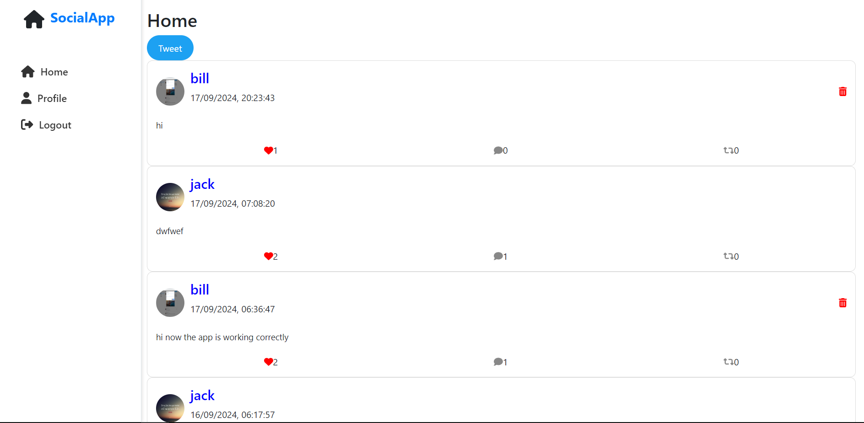

**This is the Profile page for logged In user**

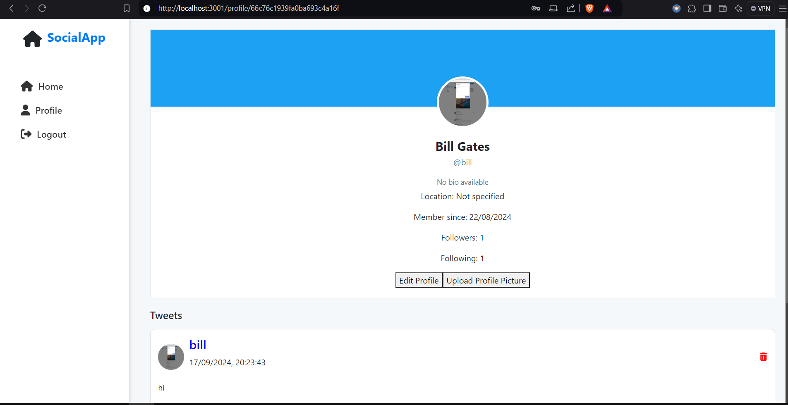

**Clicking on Tweet Button opens the Tweet Dialog**

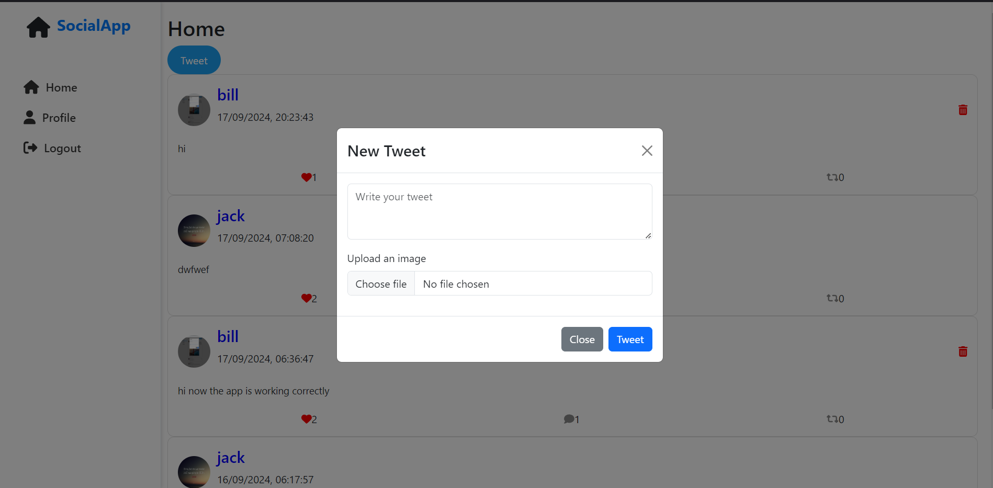

**Profile page for non-logged In user**

